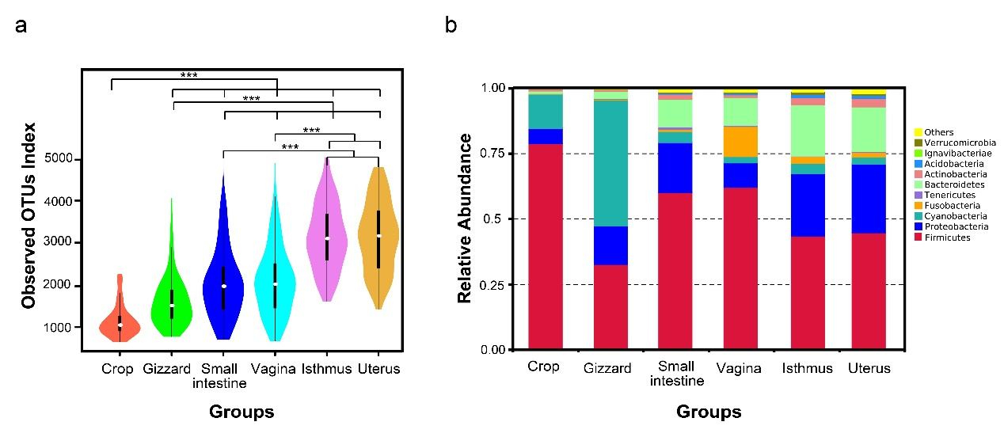
Figure S1: (a) ɑ-Diversity comparison based on the observed OTUs index, using Wilcoxon rank-sum test to determine signiﬁcant differences, all pairwise comparisons show significant difference (P < 0.001) except two comparisons (small intestine vs vagina, and uterus vs Isthmus). (b) Relative abundance of the top ten dominant microbial phyla in six different segments.

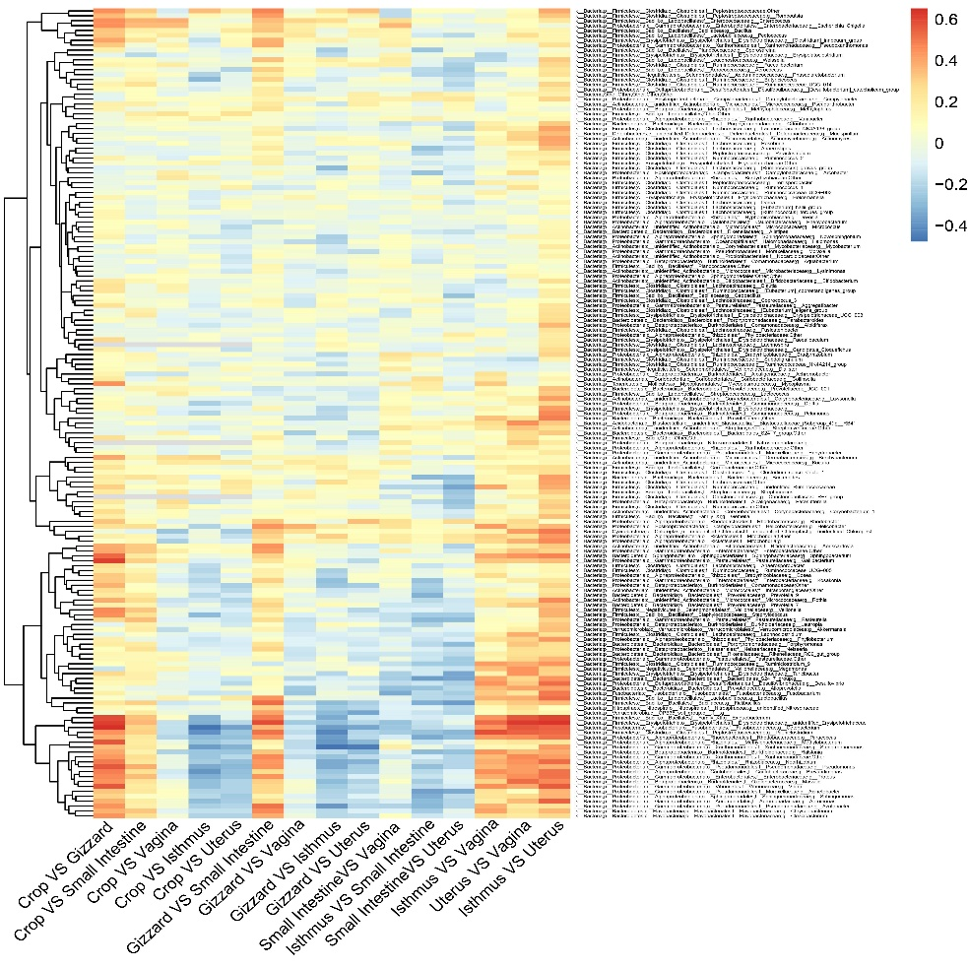
Figure S2: Relative abundance and Spearman correlation of specific microbiota among the six sites. Only microbial genera that were present in at least 461 samples (60% of the total) were plotted. Each row represents a microorganism. Among these 2475 Spearman correlation coefficient, only 362 (14.62%) of them were significantly correlated.
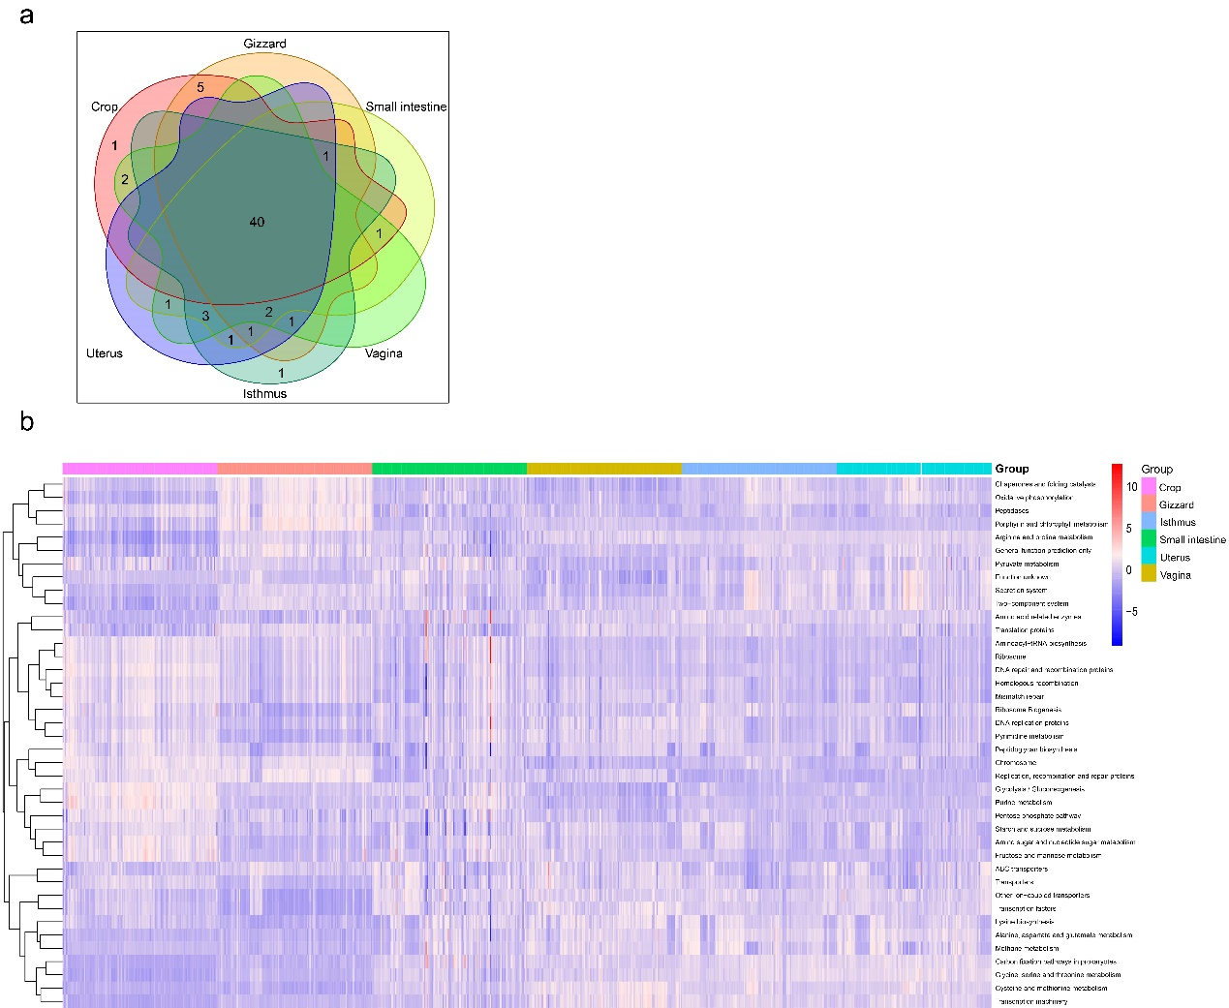
Figure S3: Comparison of the functional capacities of the reproductive and digestive microbial communities in diverse segments. (a) Overlap of the top 50 predictions among the six sites. (b) Heatmap showing the 40 overlapped predictions with different abundances among the diverse sites (see Table S4). The heatmap is colour-coded based on row z-scores.

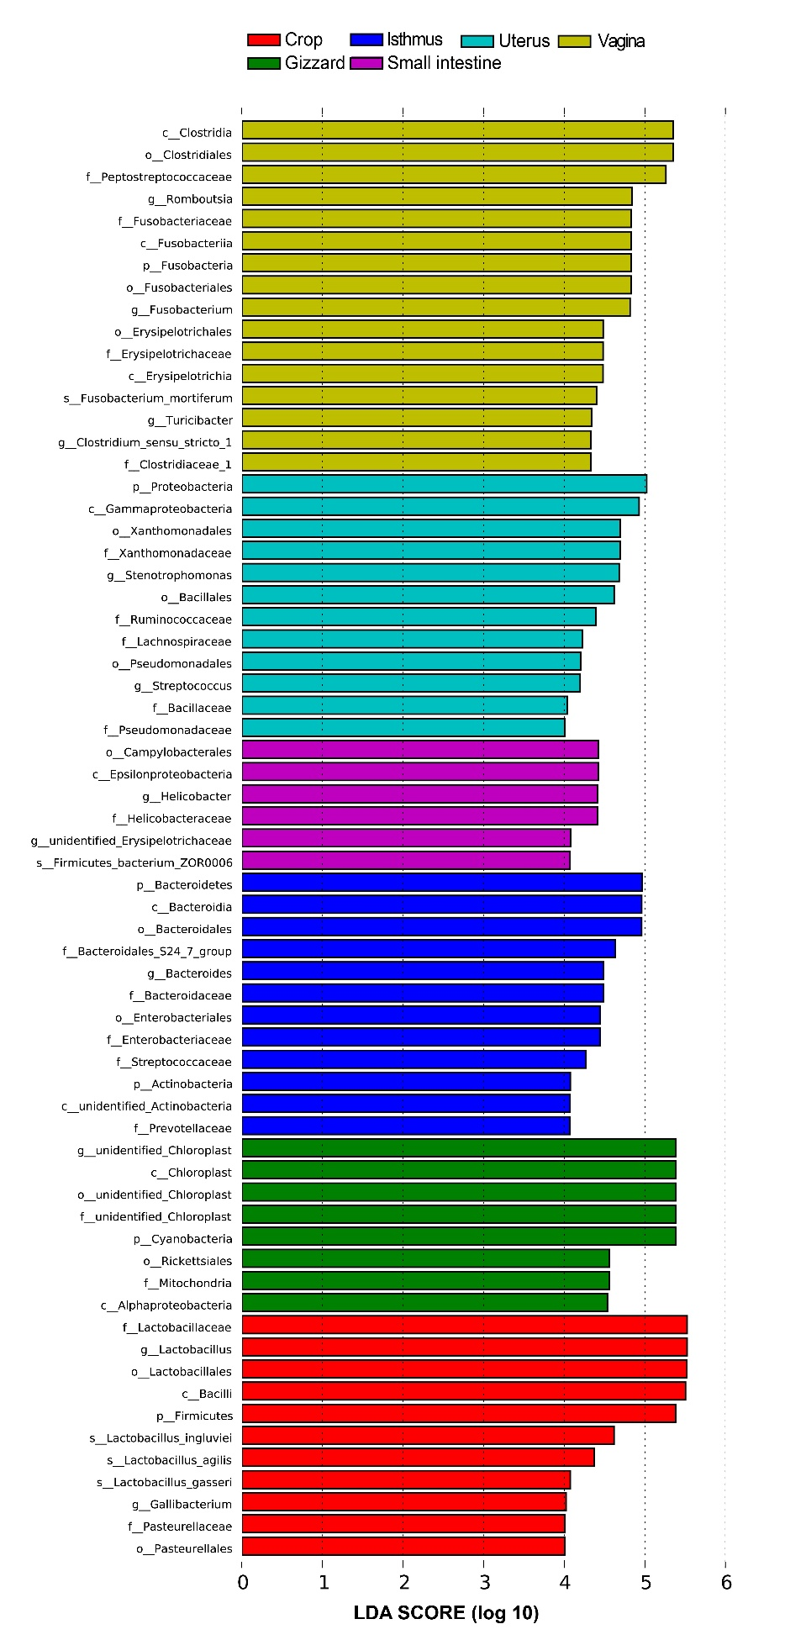
Figure S4: Map showing 65 site-associated bacterial taxa identified by LEfSe (LDA score > 4) in the test trial.

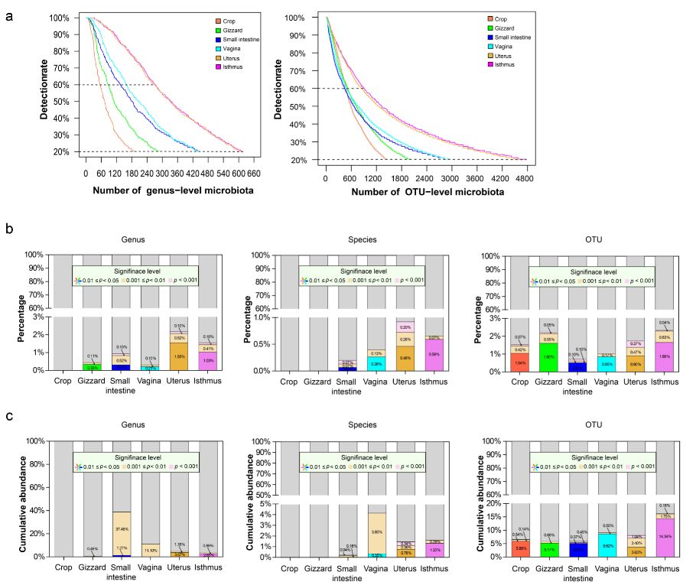
Figure S5: (a) Number of identiﬁed microbial genus and OTUs. The microorganisms with a detection rate < 20% were excluded from further analysis. (b) The percentage of number of heritable microbial genus, species and OTUs in each digestive/reproductive segment. (c) The cumulative relative abundance of heritable microbial genera, species and OTUs in each digestive/reproductive segment.

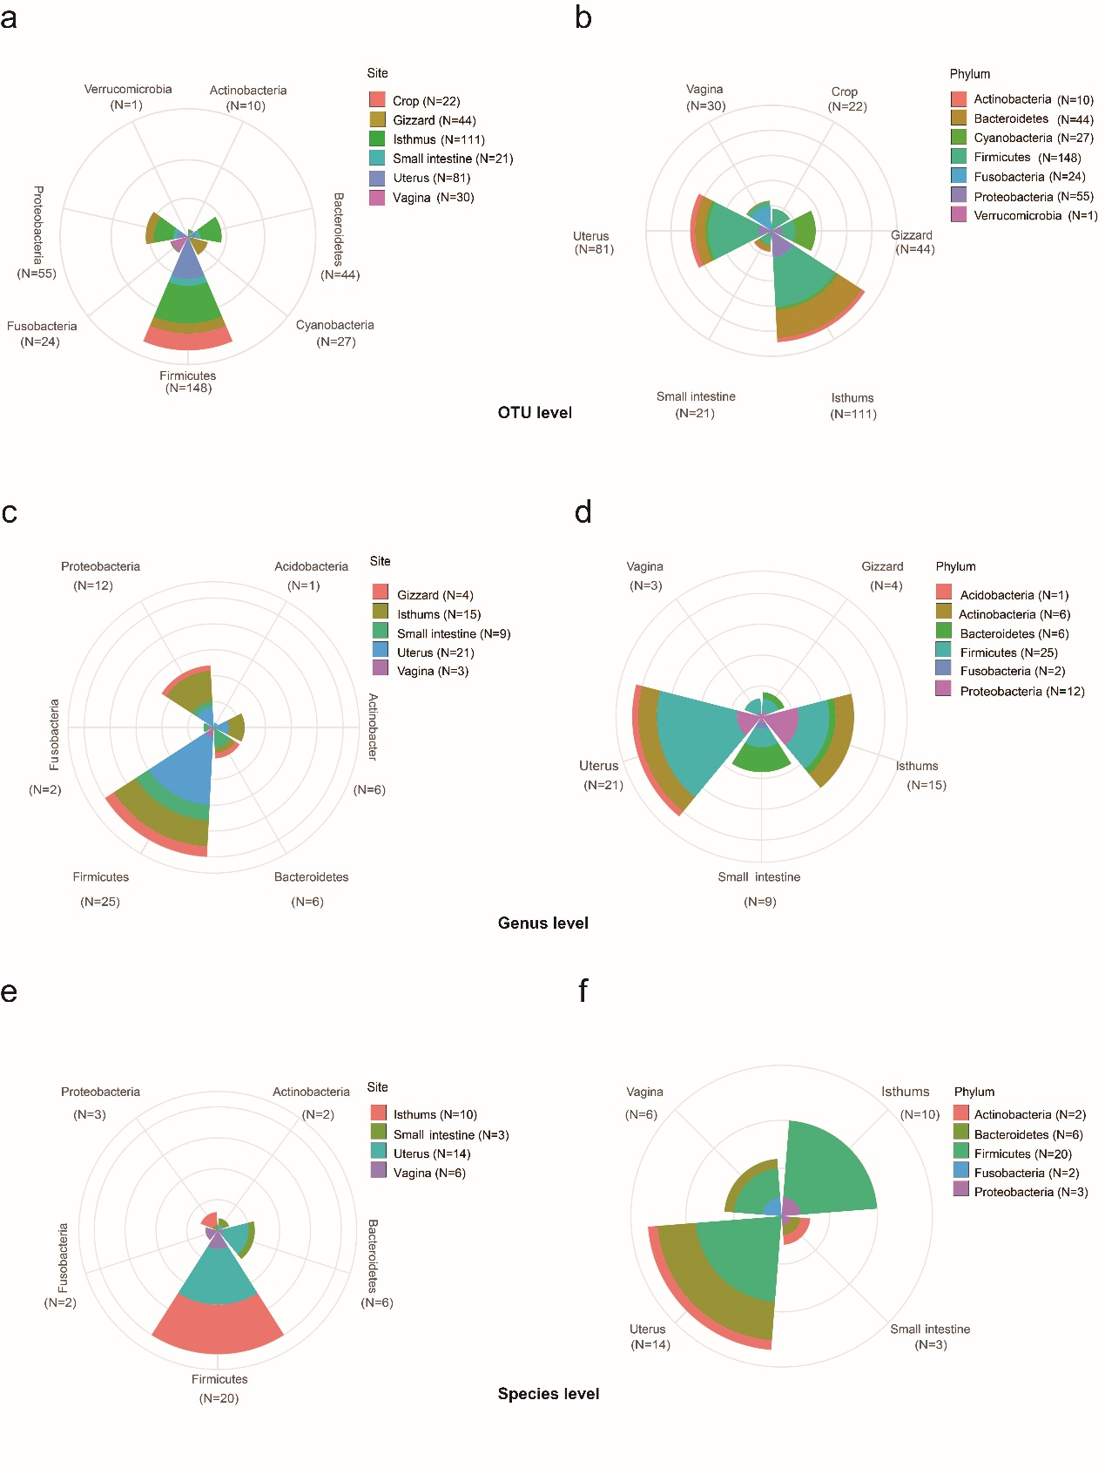
Figure S6: The number of signiﬁcantly heritable microorganism OTUs, genus and species (P < 0.05) grouped by sampling phyla (a,c,e) and site (b,d,f).

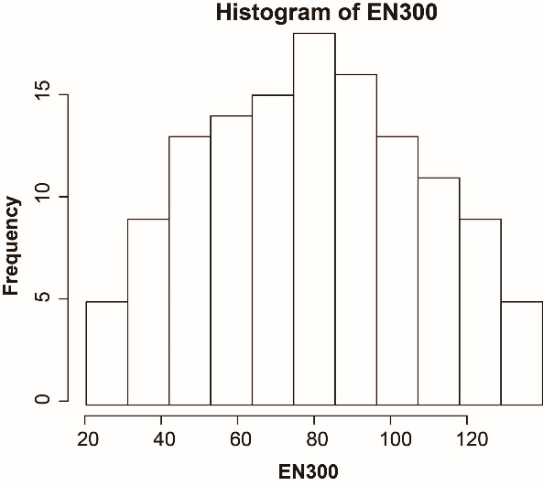
Figure S7: Distribution of egg number at 300 days of age (EN300).

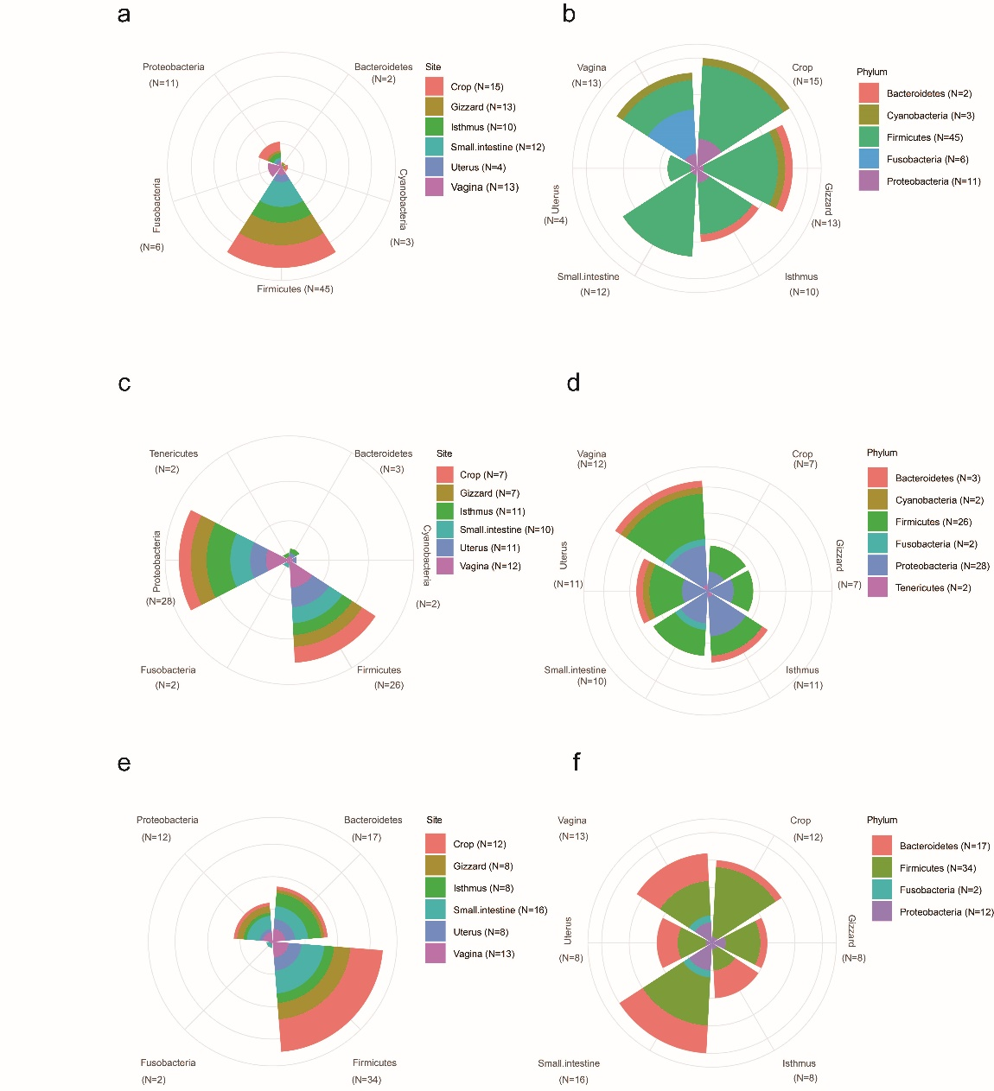
Figure S8: The microorganisms signiﬁcantly associated with egg production detected at OTU, genus and species (P < 0.05) levels grouped by sampling phyla (a,c,e) and site (b,d,f).

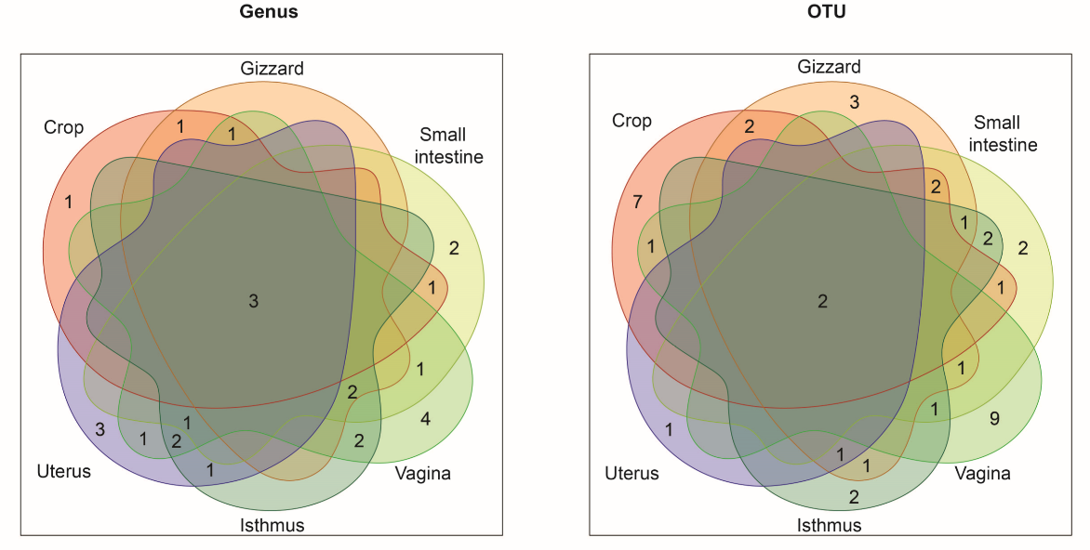
Figure S9: The number of microbial genus (left) and OTUs (right) associated with EN300 at P < 0.05 of three test methods of six segments and their overlaps with each other.

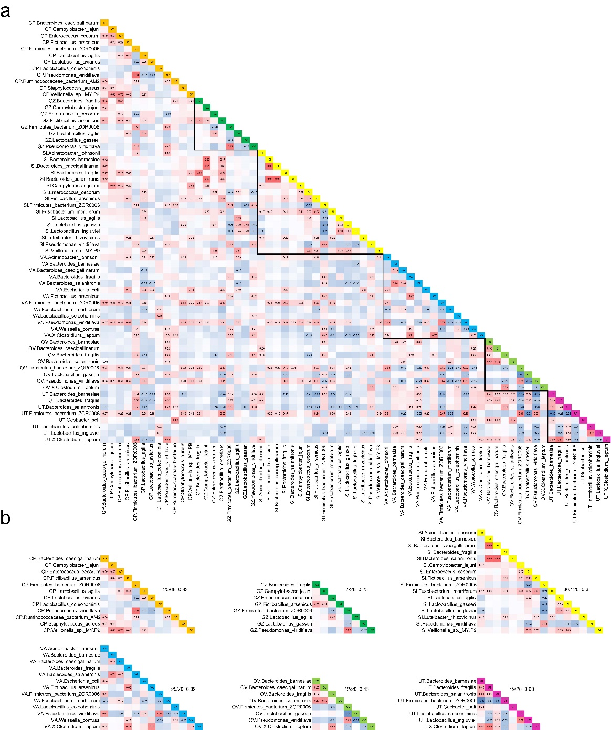
Figure S10: Pearson’ s correlations among candidate microbial species. (a) Pearson’ s correlations among candidate microbial species in six segments. (b) Pearson’ s correlations among microbial species in each segment. CP: Crop, GZ: Gizzard, SI: small intestine, UT: uterus, IS: Isthmus, VA: vagina. Red and blue tiles indicate positive and negative correlations, respectively; signiﬁcant R-values are ﬁlled in numerically (P < 0.05). The ratios on the right side of each site represents the number of significant correlations.

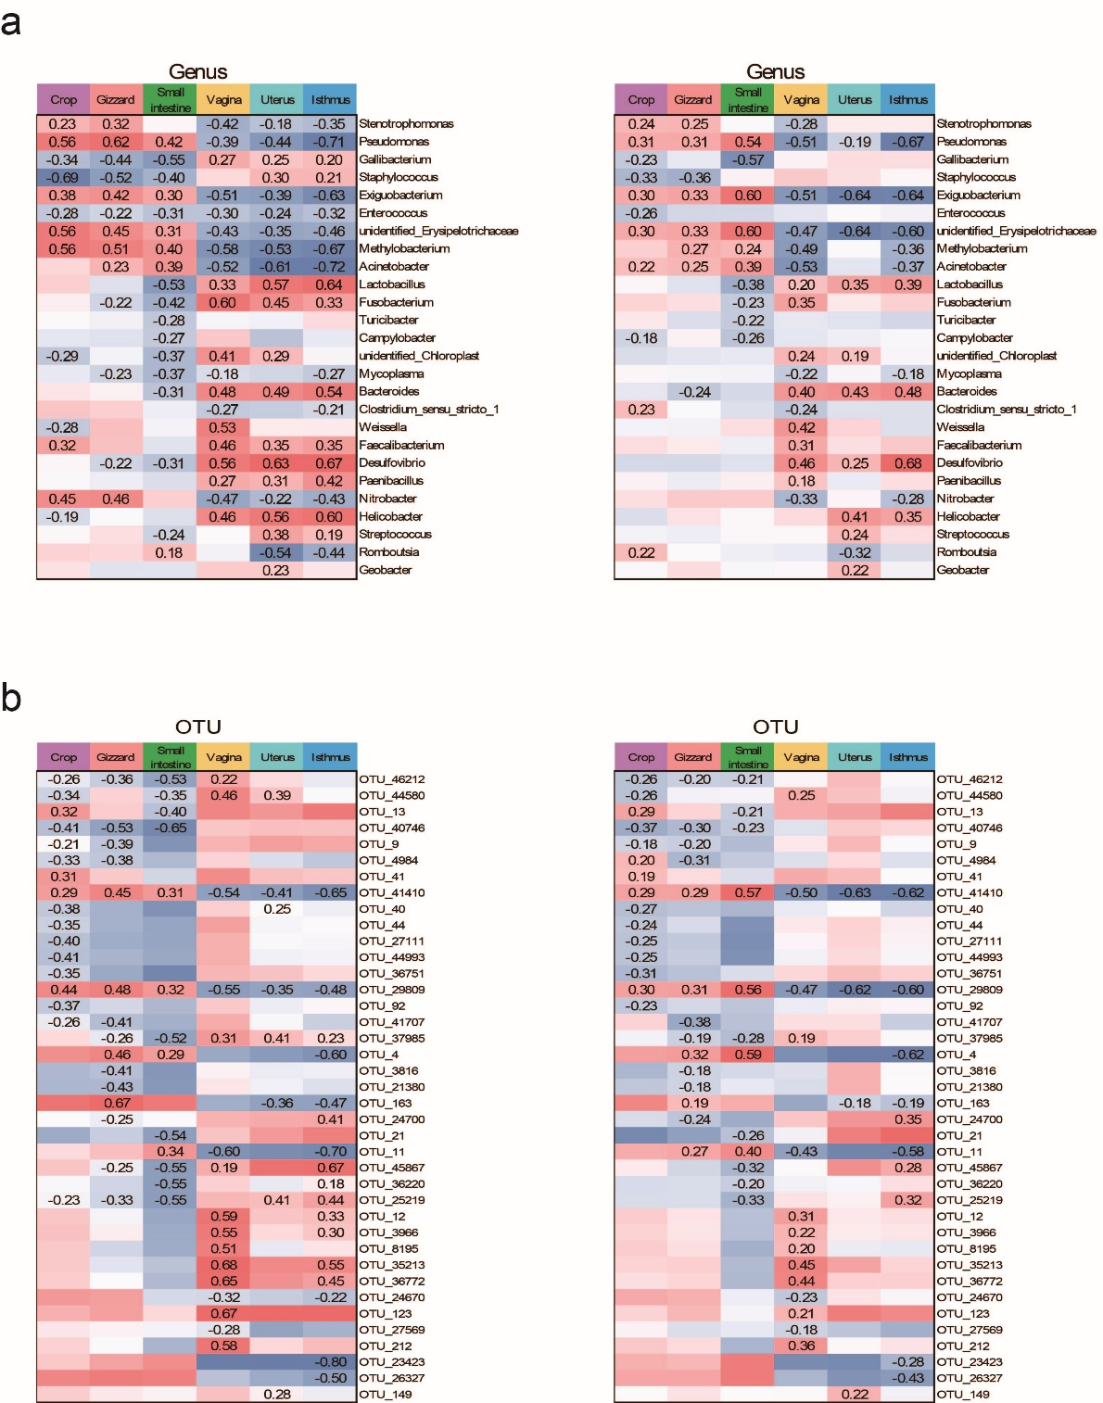
Figure S11: Spearman’ s (left) and Pearson’ s (right) correlations between EN300 and 26 microbial genus (a) / 39 OTUs (b). Red and blue tiles indicate positive and negative correlations, respectively; signiﬁcant R-values are ﬁlled in numerically (P < 0.05).

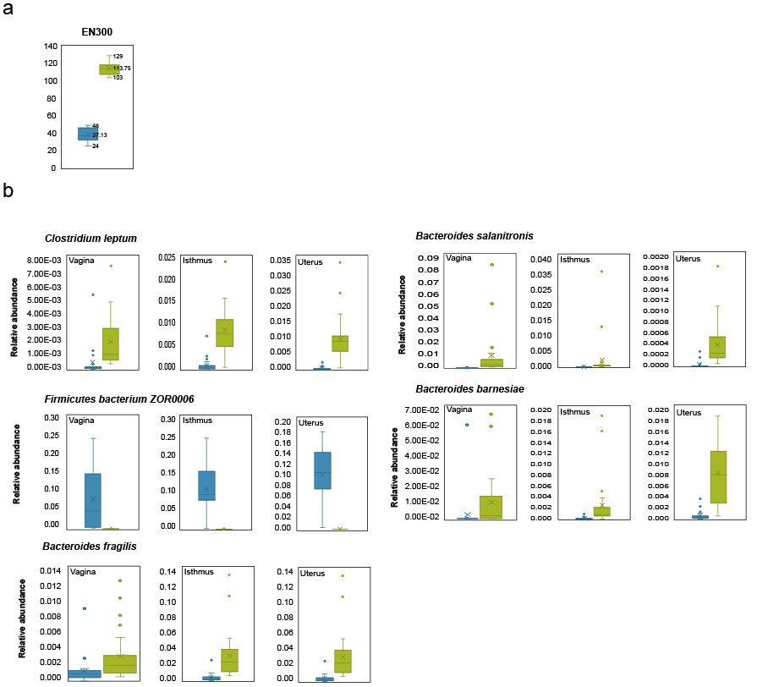
Figure S12: Differences in the relative abundance of 5 species between the 20% of birds with the highest and the 20% of birds with the lowest egg production (EN300). All comparisons were significant different. Significant levels were obtained using the permutation test with 10,000 replication times. Signiﬁcance was established at an P < 0.05.

